- Select Application Supplement from the left-hand side.
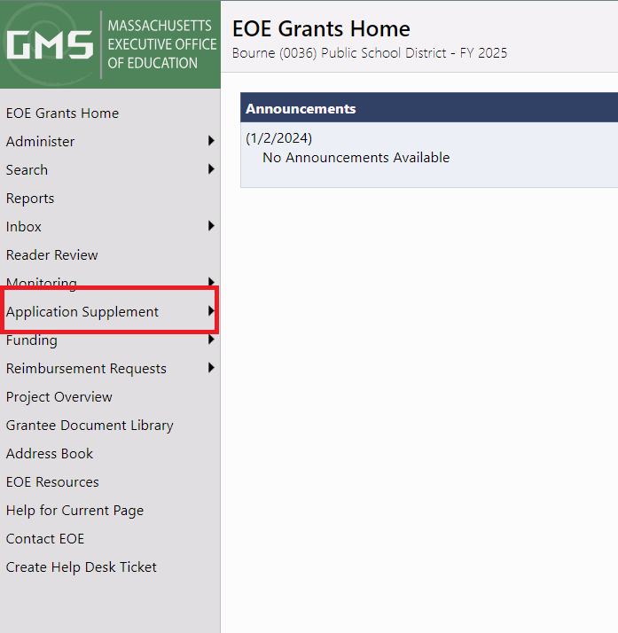

- Then ensure that you have selected 2025 and Active.
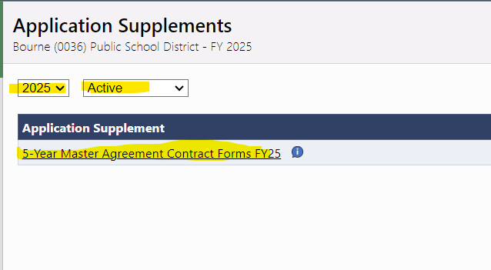

- Once the Supplement is opened, please change the status to: Application Supplement Started
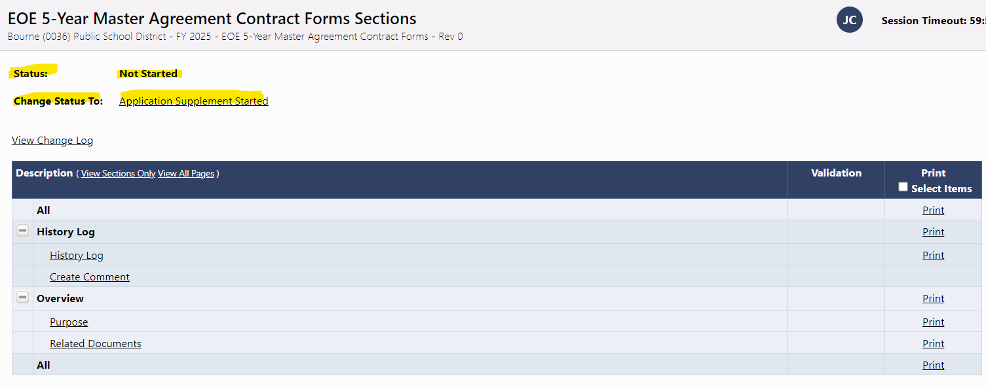
- Start with the Purpose section and the documents to download are in the Related Documents section.
