Q & A STEM Internship Webinar

- Will this presentation be recorded and shared after this meeting?
  - Yes, it'll be recorded and posted in the EOE Resources Page

- How long do we have to spend the funds?
  - We are aligning with the state fiscal year. The funds will be available for summer spending in July and August. The fiscal team will be asking for two budgets.
1.) from Sept through June 30
2.) a budget for July and August
You will have an opportunity to amend your budgets to carry forward funds for the summer to be used by August 31.
We will reach out in April or May to have you finalize your FY24 funds and identify what funds will be spent in FY25.
- Is the 100 hours for student interns to work a mandatory number? Or can a student choose to work less hours?
  - Should be approximately 100 hours. Okay if slightly below or above but 100 should be the average and it should not be, for example, 10 hours for any student.

- By the time we get the grant and onboard students through our HR Dept, the District feels it will be challenging to give students time to complete 100 hours prior to June 30. You mentioned identifying funds to be spent in FY25....would we be allowed to have student intern work this summer?
  - Yes, you will have an opportunity to amend your budgets in order to carry forward funds for the summer to be used by August 31.

- To clarify, documents for funding for SY 24 will be uploaded for signature and other info gathering, and the proposals for SY25 are due on March 1st?
  - No, both FY24 & FY25 budgets are due March 1st. You will be able to tag the budget with the fiscal year intended to spend.
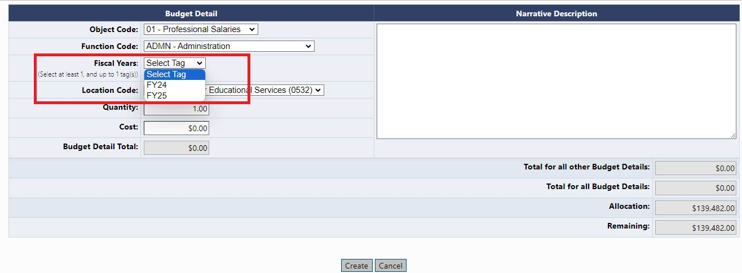

- Is the student maxed at 100 hours or can they go over and still be paid?
  - Yes, students may be paid for the time if they work more than 100 hours. On average, students should work at least 100 hours. Overall, the goal of the grant is to provide students with approximately 100 hours of internship experience.

- What percentage can be used for intern oversight?
  - There is no specific percentage. Please complete your budget as would like to spend the funds to meet the purposes of the grant, and EOE will be in touch with any feedback.

- What percentage can be used for transportation?
  - There is no specific percentage. Please complete your budget as would like to spend the funds to mee the purposes of the grant, and EOE will be in touch with any feedback.

- Last year we had until the end of Sept to submit final documentation, will we have the same this year?
  - Yes, there will be a close out period at the end of the grant.

